# 1. INTRODUCTION

## Project Methodology Definition

Project methodology is a necessary system that would be normally used when conducting a **project-based activity**, especially of those in a tremendously large scale. The system involves consideration of every aspect possible from skillsets, milestones to quality standards using various tools and techniques to create an efficient **working flow** for all individuals and departments in charge of the project developments, with the aim of **meeting the scope of project requirements**. The project usually requires the deliverables to be able to address any needs and concerns from all stakeholders.

Depending on the project’s content and workload, different types of methodology could be applied to suit the project best, but all of them ultimately ties to the following ‘ground rules’ (Cockburn, 2000):

* The **larger** a project is, the **larger** its **methodology** should be.
* More critical or important aspects of the project require **more attention** and ‘*publicly visible correctness in its construction’.*
* Any **small increase** in methodology size or density would **drastically increase** the project cost.
* **Face-to-face interaction** is the most effective communication method in conveying ideas and concepts.

## Selected Project Methodology

The project methodology applied to complete the project based on the case study scenario is the **Waterfall Model**. Waterfall model, at its core, is a **series of main phases** being arranged in a **sequential development model** (S. Balaji, 2012), as shown in the diagram in ***FIGURE 1.01***:

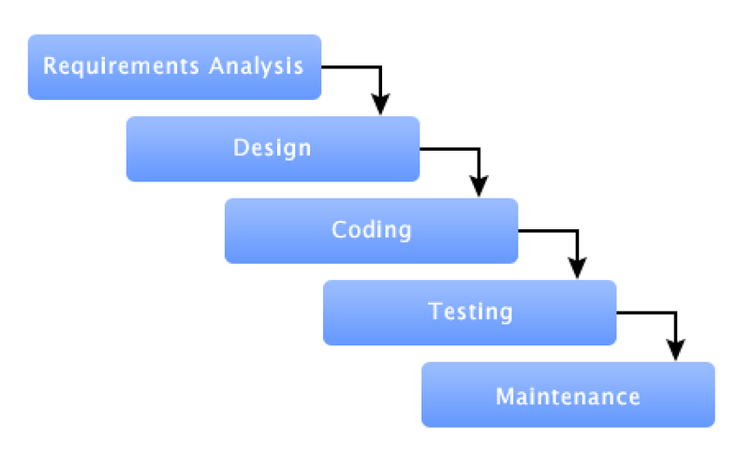

***FIGURE 1.01: Waterfall Model Basic Outline***

Waterfall model is an infamous development methodology for having the project scopes identified in advance, and having the project to **progress according the pre-defined phases** made from the identified scopes. In order to advance to certain phase, any phases before the said phase must be completed and verified.

Despite it being a rigid structure with low flexibly level, waterfall model is a nice methodology to refer with when working on similar **projects that has been attempted before**, or one that people has been familiar with its milestones entirely. The ISCMP, according to the case study, is a project where other countries such as China and Thailand have developed with years ago, and thus enabled a clear milestone reference in the current situation based on their attempts as well.

Also, due to the 4-month time restriction from the failure of previous management, the team would be in low levels of morale where most participants would lose motivation to continue with the project. Therefore, waterfall model would serve as a guideline for each participating unit so all of them would be **clear on their respective responsibilities in the shortest time possible**.

In exchange of low level of team coordination and synchronization, there is a **lower level of risk** of failing this project based on waterfall model, as conflicts between project teams and external organizations would be reduced to a minimum.

## Methodology Implementation

In this Integrated Supply Chain Management Project, the tasks would be divided into phases that would be formed into a hierarchy, where the priority of each project has been identified beforehand. Although creating a hand-written waterfall model as a project development guideline in this situation is applicable, the lack of time would make such process time-consuming for preparation alone.

Therefore, a suggestion of using the online-available software ***SpiraTeam***, where it provides a project overview, activities and lists of tasks along with risks in web application environment, which means the project model could be viewed and modified by using web-browser. The progress of each processes could be updated directly via such means, as shown in ***FIGURE 1.02***

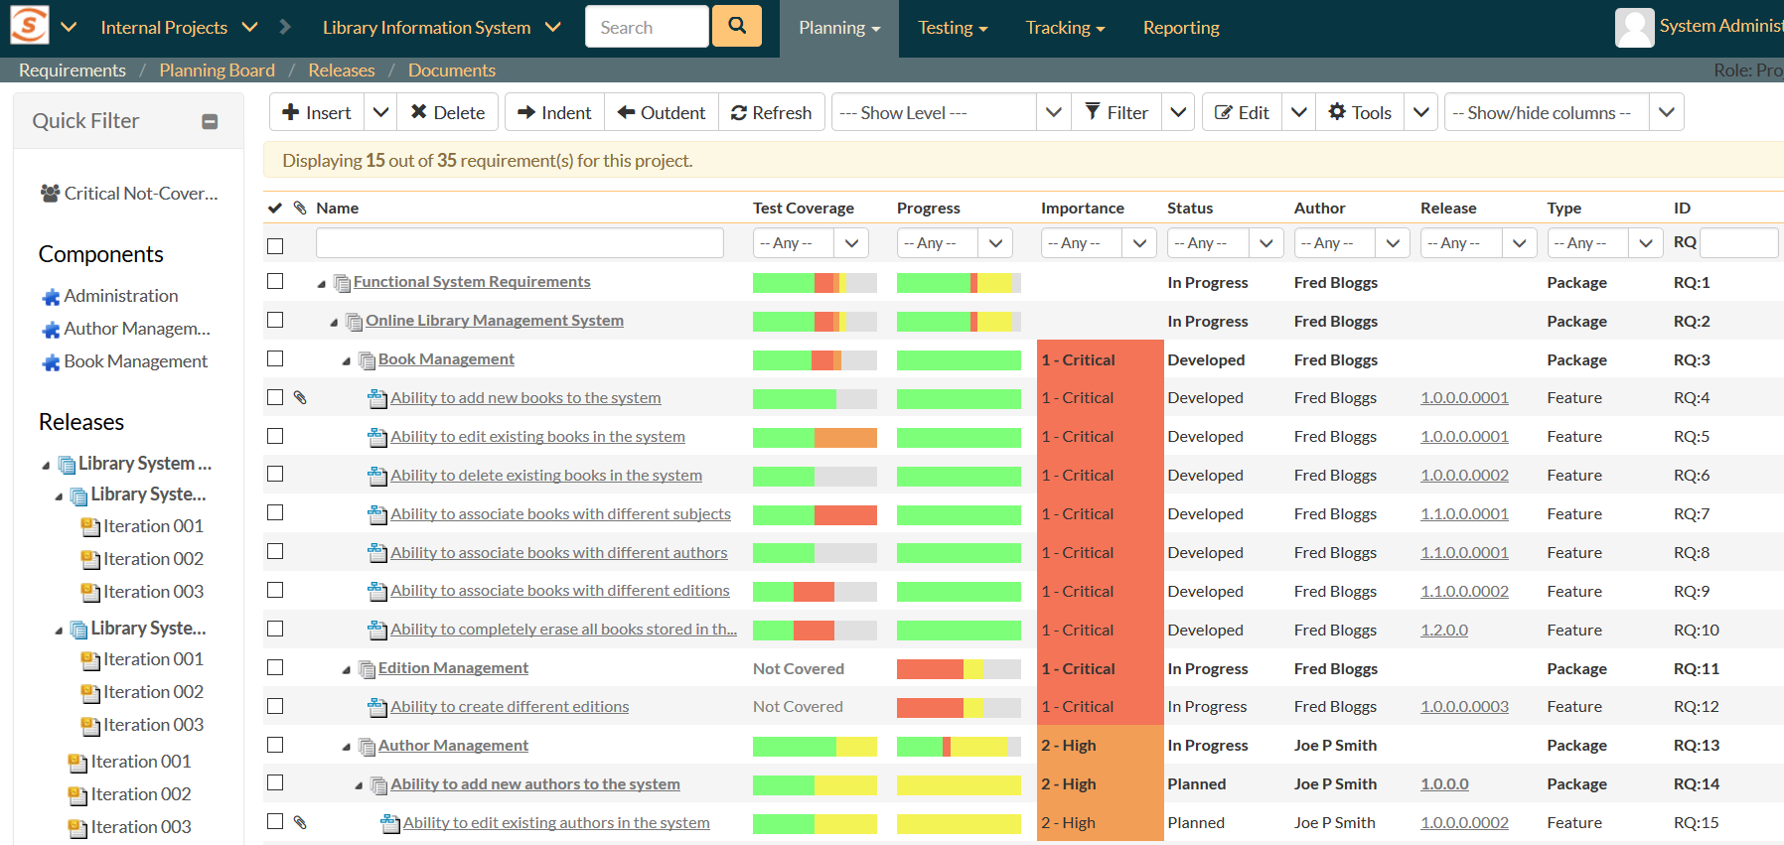

***FIGURE 1.02: SpiraTeam Waterfall Model Sample***

Based on the progress report, the coverage and priority level of each tasks could be identified easily among all departments and ensures an easier approach of follow-up to the waterfall model to complete the project.

## Project Management Process

The project management is divided into 5 phases according to their respective processes, which are **Initiating**, **Planning**, **Executing**, **Monitoring** **and** **Controlling**, and **Closing**.

1. **INITIATING**

In initiation process, the organization is required to **identify the project**, its content including objectives and phases. Once all elements of the project have been identified, the project will start on the Project Manager’s cue, in most situations.

The activities conducted in this phase normally involves **creating a project charter** to understand the key information and project specifics (Kerzner & Kerzner, 2017), while **identifying the stakeholders** of the project to determine everyone’s influence on the project’s development.

1. **PLANNING**

Planning is when the project is in the stage of writing a **guide for project executions**. All available resources would be accounted for to devise an efficient plan to complete the project and meet its requirements.

That includes the process of creating a proper **Work Breakdown Structure** (WBS), project **scope statements**, **project** **schedules** (usually in Gantt Chart format), and list of **potential risks** during the development (Kerzner & Kerzner, 2017).

1. **EXECUTING**

The project officially begins during the execution phase, where all units of the project development team are **producing the output of the project**. In the meantime, the project manager would take the role of coordinating all departments and resolve all challenges arose during the process.

While creating the **project deliverables** is usually the output from this process, **milestone reports** tend to be accompanied along with the output to ensure a brief description on the deliverables from each team during progress checking (Kerzner & Kerzner, 2017).

1. **MONITORING AND CONTROLLING**

While all the planned processes have been set in motion, the progress checking on those actions are vital to ensure the project not to be derailed via **correction actions**.

Several changes in requests or updates might occur while creating project deliverables, and thus **performance reports** and **update requests** are essential as output from this process (Kerzner & Kerzner, 2017).

1. **CLOSING**

When all the processes have been completed and corrected, the **project output would be delivered to all stakeholders** and/or potential consumers to review the product, provide feedback, and determine if the output is suitable for public release.

Regardless of the acceptance of the project deliverables, this process should produce a **completed project documentation**, **self-reflection reports** and relevant **presentation aids** as a wrap-up of a project being closed entirely (Kerzner & Kerzner, 2017).

## Knowledge Areas

The applicable knowledge areas regarding the project management on this assessment includes the following elements:

1. **Project Integration Management**

Project integration is a segment where any changes that occur during the project’s life cycle must be identified, evaluated and resolved by **coordinating all knowledge areas involved** in it (Fuller, et al., 2017).

1. **Project Scope Management**

In scope management, all objectives required by the project are determined and **devise required deliverables of the project** to ensure the process successfully addresses all the work needed for it (Fuller, et al., 2017).

1. **Project Time Management**

As the title suggests, time management is a section that deals with estimating time needed to complete the project, it’s relevant processes and create a **working schedule** that could utilize all departments in project development (Fuller, et al., 2017).

1. **Project Cost Management**

Like time management, cost management estimates the capital the project has been allocated to and determines the suitable **amount of budget** allocated to each department to ensure a smooth workflow of each processes (Fuller, et al., 2017).

1. **Project Quality Management**

While all the processes in a project must be completed within allocated periods, quality management is necessary to **make sure the deliverables from every processes meet its requirements** that was from the scope management segment (Fuller, et al., 2017).

1. **Project Human Resource Management**

**Allocating people to their respective roles** in project development comes into the responsibility of the human resource management, where each participating individuals’ skillsets and interests are analyzed to make sure highest level of efficiency could be achieved from the process (Fuller, et al., 2017).

1. **Project Communication Management**

Planning, managing and controlling the communications within the project teams is a vital aspect in managing a smooth development flow, where **project information can be collected, stored, and relayed** to desired departments in an appropriate and timely manner (Fuller, et al., 2017).

1. **Project Risk Management**

While meeting the project scopes, the risk management is a segment that is normally in charge of **identifying and analyzing the potential risks** that might occur to the project development, while respond and **resolve it immediately** when one happens in the process of project execution (Fuller, et al., 2017).

1. **Project Procurement Management**

In several occasions, procurement management is necessary to **acquire goods and services from outside of the project team or organization**, usually with aim of integrating the goods and services into the project development to increase the quality of the project deliverables or reducing the cost of creating one from scratch (Fuller, et al., 2017).